**WEEK 4 ASSIGNMENT**

**TO PERFORM SQL QUERIES ON HACKER RANK**

* **Questions related to SELECT command**

**The CITY table is described as follows:**

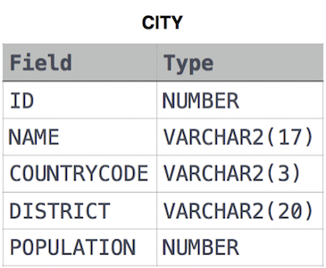

1. **Query all columns for all American cities in the CITY table with populations larger than 100000. The CountryCode for America is USA.**

**Solution:**

select Id,Name,CountryCode,District,Population

from CITY

where CountryCode="USA" and Population>100000;

1. **Query the NAME field for all American cities in the CITY table with populations larger than 120000. The *CountryCode* for America is USA**

**Solution:**

select NAME from CITY

where POPULATION>120000 and COUNTRYCODE="USA"

1. **Query all columns (attributes) for every row in the CITY table.**

**Solution:**

select *from CITY

1. **Query all columns for a city in CITY with the *ID* 1661.**

**Solution:**

select * from CITY where ID=1661

1. **Query all attributes of every Japanese city in the CITY table. The COUNTRYCODE for Japan is JPN.**

**Solution:**

select * from CITY

where COUNTRYCODE = "JPN"

1. **Query the names of all the Japanese cities in the CITY table. The COUNTRYCODE for Japan is JPN.**

**Solution:**

select name from CITY

where COUNTRYCODE = "JPN"

* **Weather Observation Station Problems**

**The STATION table is described as follows:**

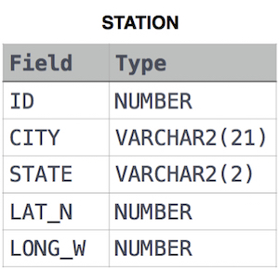

1. **Query a list of CITY and STATE from the STATION table.**

**Solution:**

select CITY,STATE from STATION;

1. **Query a list of CITY names from STATION for cities that have an even ID number. Print the results in any order, but exclude duplicates from the answer.**

**Solution:**

select distinct city from station where id % 2 = 0;

1. **Find the difference between the total number of CITY entries in the table and the number of distinct CITY entries in the table.**

**Solution:**

select count(city)-count(distinct city)

from station ;

1. **Query the two cities in STATION with the shortest and longest *CITY* names, as well as their respective lengths (i.e.: number of characters in the name). If there is more than one smallest or largest city, choose the one that comes first when ordered alphabetically.**

**Solution** :

select city,length(city)from station order by length(city),city limit 1;

select city,length(city)from station order by length(city) desc limit 1;

1. **Query the list of *CITY* names starting with vowels (i.e., a, e, i, o, or u) from STATION. Your result *cannot* contain duplicates.**

**Solution:**

select city from station

where city like 'a%' or

city like 'e%' or

city like 'i%' or

city like 'o%' or

city like 'u%';

1. **Query the list of *CITY* names ending with vowels (a, e, i, o, u) from**

**STATION. Your result *cannot* contain duplicates.**

**Solution:**

select distinct city from station

where city like '%a' or

city like '%e' or

city like '%i' or

city like '%o' or

city like '%u';

1. **Query the list of *CITY* names from STATION which have vowels (i.e., *a*, *e*, *i*, *o*, and *u*) as both their first *and* last characters. Your result cannot contain duplicates.**

**Solution:**

select distinct city from station

where ( city like '%a' or

city like '%e' or

city like '%i' or

city like '%o' or

city like '%u')

and

(city like 'a%' or

city like 'e%' or

city like 'i%' or

city like 'o%' or

city like 'u%');

1. **Query the list of *CITY* names from STATION that *do not start* with vowels. Your result cannot contain duplicates.**

**Solution:**

select distinct city from station

where city not like 'a%' and

city not like 'e%' and

city not like 'i%' and

city not like 'o%' and

city not like 'u%';

1. **Query the list of *CITY* names from STATION that *do not start* with vowels. Your result cannot contain duplicates.**

**Solution:**

select distinct city from station

where city not like 'a%' and

city not like 'e%' and

city not like 'i%' and

city not like 'o%' and

city not like 'u%';

**16.Query the list of *CITY* names from STATION that *do not end* with vowels.**

**Your result cannot contain duplicates.**

**Solution:**

select distinct city from station

where city not like '%a' and

city not like '%e' and

city not like '%i' and

city not like '%o' and

city not like '%u';